**Experiment 11 - Intermediate code generation- Quadruple, Triple, Indirect Triple**

RA1911003010699

Rahul Kumar

Aim:

A program to implement Intermediate code generation – Quadruple, Triple, Indirect Triple.

Algorithm:

The algorithm takes a sequence of three-address statements as input. For each three address statements of the form a:= b op c perform the various actions. These are as follows:

* Invoke a function getreg to find out the location L where the result of computation b op c should be stored.
* Consult the address description for y to determine y'. If the value of y currently in memory and register both then prefer the register y' . If the value of y is not already in L then generate the instruction MOV y' , L to place a copy of y in L.
* Generate the instruction OP z' , L where z' is used to show the current location of z. if z is in both then prefer a register to a memory location. Update the address descriptor of x to indicate that x is in location L. If x is in L then update its descriptor and remove x from all other descriptors.
* If the current value of y or z have no next uses or not live on exit from the block or in register then alter the register descriptor to indicate that after execution of x : = y op z those register will no longer contain y or z.

Code:

OPERATORS = set(['+', '-', '*', '/', '(', ')']) PRI = {'+': 1, '-': 1, '*': 2, '/': 2} def infix_to_postfix(formula):

stack = [] output = '' for ch in formula:

if ch not in OPERATORS: output += ch elif ch == '(': stack.append('(') elif ch == ')':

while stack and stack[-1] != '(':

output += stack.pop()

stack.pop()

else:

while stack and stack[-1] != '(' and PRI[ch] <= PRI[stack[-1]]: output += stack.pop()

stack.append(ch)

while stack:

output += stack.pop()

return output

def infix_to_prefix(formula):

op_stack = [] exp_stack = [] for ch in formula:

if not ch in OPERATORS: exp_stack.append(ch) elif ch == '(':

op_stack.append(ch) elif ch == ')':

while op_stack[-1] != '(': op = op_stack.pop() a = exp_stack.pop() b = exp_stack.pop() exp_stack.append(op+b+a)

op_stack.pop()

else:

while op_stack and op_stack[-1] != '(' and PRI[ch] <= PRI[op_stack[-1]]:

op = op_stack.pop() a = exp_stack.pop() b = exp_stack.pop() exp_stack.append(op+b+a)

op_stack.append(ch)

while op_stack:

op = op_stack.pop() a = exp_stack.pop() b = exp_stack.pop() exp_stack.append(op+b+a)

return exp_stack[-1] def generate3AC(pos): print("### THREE ADDRESS CODE GENERATION ###")

exp_stack = [] t = 1 for i in pos:

if i not in OPERATORS:

exp_stack.append(i)

else: print(f't{t} := {exp_stack[-2]} {i} {exp_stack[-1]}')

exp_stack = exp_stack[:-2] exp_stack.append(f't{t}') t += 1

def Quadruple(pos):

stack = [] op = [] x = 1

for i in pos:

if i not in OPERATORS: stack.append(i) elif i == '-':

op1 = stack.pop() stack.append("t(%s)" % x)

print("{0:^4s} | {1:^4s} | {2:^4s}|{3:4s}".format(

i, op1, "(-)", " t(%s)" % x))

x = x+1 if stack != []:

op2 = stack.pop() op1 = stack.pop()

print("{0:^4s} | {1:^4s} | {2:^4s}|{3:4s}".format(

"+", op1, op2, " t(%s)" % x)) stack.append("t(%s)" % x) x = x+1 elif i == '=':

op2 = stack.pop() op1 = stack.pop()

print("{0:^4s} | {1:^4s} | {2:^4s}|{3:4s}".format(i, op2, "(-)", op1))

else:

op1 = stack.pop() op2 = stack.pop()

print("{0:^4s} | {1:^4s} | {2:^4s}|{3:4s}".format(

i, op2, op1, " t(%s)" % x))

stack.append("t(%s)" % x) x = x+1

def Triple(pos): stack = [] op = [] x = 0 for i in pos:

if i not in OPERATORS:

stack.append(i) elif i == '-':

op1 = stack.pop() stack.append("(%s)" % x)

print("{0:^4s} | {1:^4s} | {2:^4s}".format(i, op1, "(-)")) x = x+1 if stack != []:

op2 = stack.pop() op1 = stack.pop()

print("{0:^4s} | {1:^4s} | {2:^4s}".format("+", op1, op2))

stack.append("(%s)" % x) x = x+1 elif i == '=':

op2 = stack.pop() op1 = stack.pop() print("{0:^4s} | {1:^4s} | {2:^4s}".format(i, op1, op2))

else:

op1 = stack.pop() if stack != []:

op2 = stack.pop()

print("{0:^4s} | {1:^4s} | {2:^4s}".format(i, op2, op1))

stack.append("(%s)" % x) x = x+1

def IndirectTriple(pos):

stack = [] op = [] x = 0 c = 0 for i in pos:

if i not in OPERATORS:

stack.append(i) elif i == '-':

op1 = stack.pop() stack.append("(%s)" % x)

print("{0:^4s} | {1:^4s} | {2:^4s} | {3:^5d}".format(i, op1, "(-)", c)) x = x+1 if stack != []:

op2 = stack.pop() op1 = stack.pop()

print("{0:^4s} | {1:^4s} | {2:^4s} | {3:^5d}".format(

"+", op1, op2, c)) stack.append("(%s)" % x) x = x+1 c = c+1 elif i == '=':

op2 = stack.pop() op1 = stack.pop()

print("{0:^4s} | {1:^4s} | {2:^4s} | {3:^5d}".format(i, op1, op2, c)) c = c+1

else:

op1 = stack.pop() if stack != []:

op2 = stack.pop()

print("{0:^4s} | {1:^4s} | {2:^4s} | {3:^5d}".format(

i, op2, op1, c))

stack.append("(%s)" % x) x = x+1 c = c+1

z = 35 print("Statement|Location") for i in range(0, c): print("{0:^4d} |{1:^4d}".format(i, z)) z = z+1

expres = input("ENTER THE EXPRESSION: ") pre = infix_to_prefix(expres) pos = infix_to_postfix(expres) generate3AC(pos) print("=====Quadruple=====")

print("Op | Src1 | Src2| Res") Quadruple(pos) print("=====Tripple=====") print("Op | Src1 | Src2") Triple(pos) print("====Indirect Tripple====") print("Op | Src1 | Src2 |Statement")

IndirectTriple(pos)

**Output:**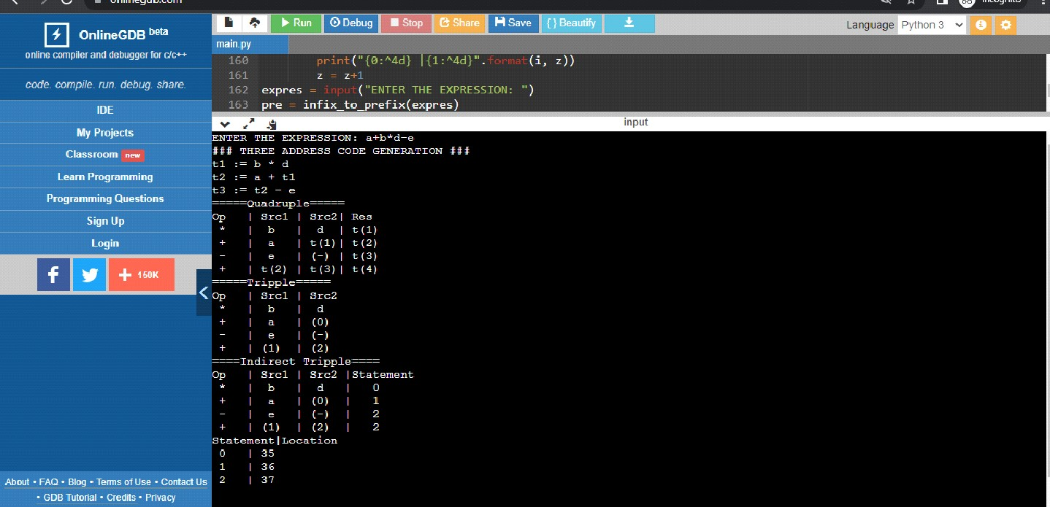

Result:

The program was successfully compiled and run.